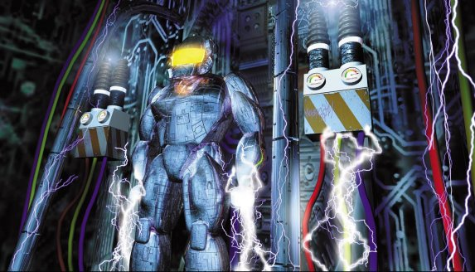

MSc in Games Programming
at the University of Hull, UK
"Game development is a fast-growing entertainment field, with a lot to offer professionally and creatively. While enthusiasm is crucial, skills and knowledge are needed. It is as competitive as any entertainment industry, and it's not easy to land that first job. Getting a relevant education is a first step to success." - Jason Della Rocca, Program Director, International Game Developers Association
During the last twenty years, electronic games have gone from a curiosity to one of the most popular forms of entertainment for children and adults alike. For a number of years the computer games industry has made more money than the film industry; about £1.6 Billion in 2001 in the UK alone.
This 1 year MSc is designed to give a broad introduction to games development combined with an in depth study of the technical aspects of game programming and production. Students will learn advanced programming methods and apply them to computer game problems. These will include real time graphics, artificial intelligence and the use of applied physics. In addition to these specialist game related areas students should understand, and be able to implement many fundamental algorithms relating to 3D graphics, including ray tracing, radiosity, lighting, shadows, reflections, transparency, texture mapping and rendering. Specific programming methods for different gaming platforms will be covered.
It is generally true that the personal computer or games console is the most advanced item of technology kept in the family home. The software that uses this advanced hardware to its maximum capabilities are the games that are played. For these reasons experts in computer games programming are highly regarded in the field of software engineering and graduates from this computer games MSc. will have a skill set in demand across the whole of the software development industry and technology sector.
More information can be found on the internet at: www.mscgames.com

英国赫尔大学计算机系

数字游戏编程专业硕士学位
"游戏软件开发是一门发展迅速的娱乐商业领域，它不仅提供了无限的空间来发挥人们的想象力和创造力，同时, 也为当今世界提供了巨大的就业机会。然而，要投身这一领域，仅有热情是远远不够的， 掌握有关的技能和知识是最基本的要求。这一领域的竞争不亚于任何其他的娱乐工业领域，因此涉足这一领域并不是一件十分容易的事情。接受相关的教育是你成功的第一步。" - Jason Della Rocca, Program Director, 国际游戏开发商协会
在过去二十年间， 电子游戏已从最初的新鲜事物发展成为当今最为重要的娱乐方式之一。多年以来，计算机游戏工业所创造的商业利润一直超过电影制造业。仅就英国而言，在2001年来自游戏软件工业的收入大约是16 亿英镑。

数字游戏编程硕士学位专业是我校面向游戏开发领域而开设的一年制课程。它将全面而深入地介绍游戏编程中用到的基本知识和基本技能及其在编程实践中的应用。在这门课程中，学生将学习一些先进的编程技术并会运用这些技术编写具体的计算机游戏。课程的内容将包括实时计算机图形学，人工智能， 以及应用物理知识的使用。学生将了解和学会运用许多有关三维计算机图形学的基本算法， 包括光线跟踪算法，纹理映射算法，辐射度方法等。 此外，该课程还将介绍针对不同游戏平台而建立的特殊的编程方法。

一般说来，家庭所拥有的最先进的游戏设备是个人电脑和游戏机，而且只有计算机游戏才能最大限度地利用这些硬件资源。因此，精通于计算机游戏编程的专家在软件工程领域是备受尊重的。 毕业于本专业的硕士研究生将能够适应软件开发工业与技术的各个方面的要求。
更多的信息可从以下互联网获取: www.mscgames.com

